**Structure and Regulation:**

The US banking system is primarily regulated by the Federal Reserve System (Fed), the Federal Deposit Insurance Corporation (FDIC), and the Office of the Comptroller of the Currency (OCC).

The Federal Reserve System (FRS) is the central bank of the United States. Often called the Fed, it is arguably the most influential financial institution in the world. It was founded to provide the country with a safe, flexible, and stable monetary and financial system.1 The Fed has a board of seven members and 12 Federal Reserve banks, each operating as a separate district with their own presidents.

The Fed's main duties include conducting national monetary policy, supervising and regulating banks, maintaining financial stability, and providing banking services.

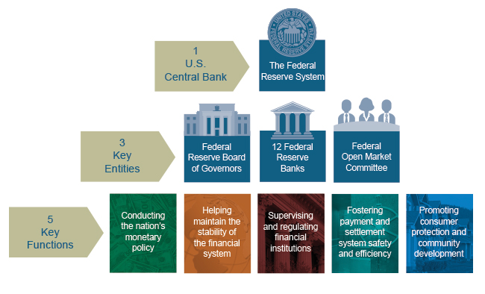

The Federal Open Market Committee (FOMC) is the Federal Reserve's main monetary policymaking body. It is responsible for open market operations, which is buying and selling government securities to influence the amount of money banks keep in reserve.

The FOMC includes the Board of Governors (or the Federal Reserve Board (FRB) as it's also called), the president of the Federal Reserve Bank of New York, and the presidents of four other regional Federal Reserve Banks who serve on a rotating basis.

The committee is responsible for monetary policy decisions, which are categorized into three areas: maximizing employment, stabilizing prices, and moderating long-term interest rates.

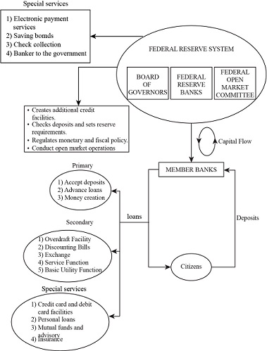

**There are two main types of banks**: commercial banks and investment banks. Commercial banks focus on lending and deposit-taking, while investment banks focus on capital markets and securities trading.

**Types of Banks:**

**Commercial Banks:** These are the most common type of bank, providing basic banking services such as checking and savings accounts, loans, and credit cards. Examples include JPMorgan Chase, Bank of America, and Wells Fargo.

**Investment Banks:** These banks focus on capital markets, securities trading, and mergers and acquisitions. Examples include Goldman Sachs, Morgan Stanley, and Bank of America Merrill Lynch.

**Community Banks:** These smaller banks focus on serving local communities and often have a more personal touch. Examples include local credit unions and community banks.

**Digital Banks:** These are online-only banks that offer digital banking services, often with lower fees and higher interest rates. Examples include Chime and Simple.

**Financial Services and Products:**

Checking and Savings Accounts: These are the most common types of bank accounts, used for everyday transactions and savings.

Loans: Banks offer various types of loans, including personal loans, mortgages, and credit cards.

Credit Cards: These are a type of loan that allows customers to borrow money for purchases and pay back with interest.

Investments: Banks offer investment products such as stocks, bonds, and mutual funds to help customers grow their wealth.

**Key Players and Organizations:**

Federal Reserve System (Fed): The central bank of the United States, responsible for setting monetary policy and regulating banks.

Federal Deposit Insurance Corporation (FDIC): An agency that insures deposits up to $250,000 and regulates banks.

Office of the Comptroller of the Currency (OCC): A regulatory agency responsible for chartering and supervising national banks and federal savings associations.

American Bankers Association (ABA): A trade association that represents the banking industry and provides resources for bankers and students.

**Industry Trends and Challenges:**

Digital Transformation: The banking industry is undergoing significant digital transformation, with many banks investing in digital platforms and services to stay competitive.

Regulatory Compliance: Banks must comply with various regulations, such as the Dodd-Frank Act, which aims to improve financial stability and consumer protection.

Cybersecurity: Banks face significant cybersecurity risks, with data breaches and hacking attempts being a major concern

**The key differences between the US and Indian banking systems are:**

**Regulation and Oversight:**

The Indian banking system is more tightly regulated by the Reserve Bank of India (RBI), which acts as the central bank and primary regulator. In contrast, the US banking system is regulated by multiple agencies like the Federal Reserve, FDIC, and OCC.

The RBI is known to be more proactive in its oversight and quicker to intervene in case of any issues, compared to the slower response seen in the US during the SVB crisis.

**Deposit Base and Concentration:**

Indian banks have a more diversified deposit base, both geographically and across industries, unlike the highly concentrated deposits at SVB which were primarily from the tech/startup sector.

The majority of deposits in Indian banks are retail deposits, whereas SVB had a high concentration of bulk, uninsured deposits.

**Held-to-Maturity (HTM) Investments:**

The RBI has strict limits on the amount of a bank's balance sheet that can be allocated to the HTM category, unlike the US where SVB had over $100 billion in HTM investments.

**Financial Inclusion:**

The Indian banking system has a stronger focus on financial inclusion, with initiatives like the no-frills accounts, self-help group linkages, and the use of business correspondents to reach the unbanked.

In contrast, the US banking system has historically been more focused on serving the needs of larger commercial and investment banking clients.

**Multilayered Structure:**

The Indian banking system is more multilayered, with a mix of commercial banks, regional rural banks, cooperative banks, and other specialized institutions, compared to the more consolidated US banking landscape.

In summary, the Indian banking system is considered more stable and resilient compared to the US, due to tighter regulation, a more diversified deposit base, and a stronger focus on financial inclusion



